**Design in C# Final Examination**

**Class:COM20-A**

**Project: Photo Manager**

**Requirements**: Windows form Photo Manager with functions to add, save, open and adding tags to photo.

**Done** **by**: Avgustin Chynarbekov

**Photo Manager**

This project made with C#, windows form. This project for Final Exam in C# course.

Project look like that:

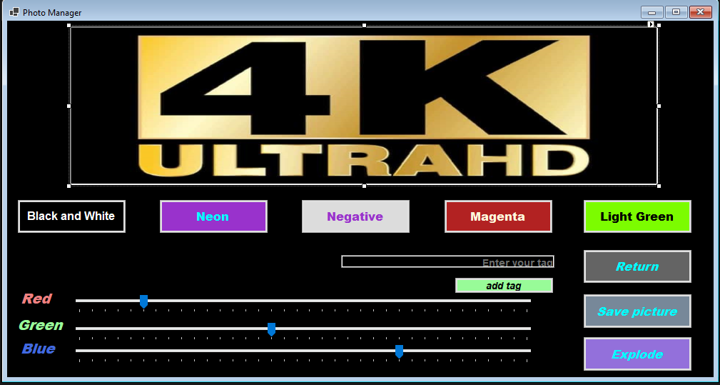

ImageView, buttons to change render, functional buttons like return, save picture, open image and Red, Green and Blue color’s slider.

You can open, save images and add tags.